DOCUMENT REGISTER – MOOREVILLE TERRACE, RATHDOWNEY

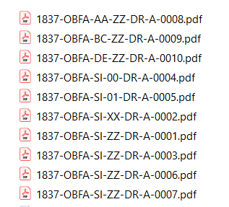
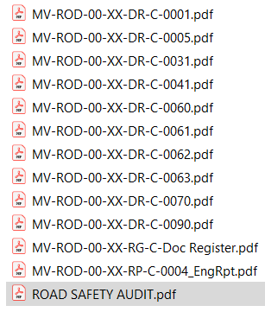
EIA Screening Determination
Copy Leinster Express Advert 21/07/2020

